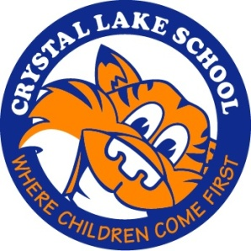
Crystal Lake School PTO Volunteer Form

Please check the activities you are interested in and we will be in touch with you closer to the time of the event.

Thank you for your interest in helping our PTO! We appreciate it!

Contact Information (please print clearly):

Name: ______________________________________________________

Telephone: (Home): __________________________________________

(Cell): ____________________________________________

Email: ______________________________________________________

I am interested in helping out with the following events:

___Book Fair (December 2-4, 2015)

___Cultural Arts/Visiting Authors

___Field Day (May/June 2016)

___ Halloween Party (October 23, 2015)

___Mileage Club

___Movie Night (February 2016)

___Plant Sale (May 2016)

___Teacher Appreciation Luncheon (May 2016)

___Yearbook

