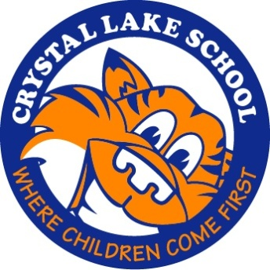
Schedule of PTO Events/Fundraisers
2019-2020 School Year

Month | Fundraiser | Event
September | Fall Spirit Wear | Fall Running Club
October | Gift Cards | Halloween Party
November | Book Fair  Teachers’ Experience | Veteran’s Day Reception
December | Holiday Shoppe? | Visiting Author
January |  | Ron-A-Roll (5th and 6th Grades)
February |  | Movie Night
March | Munsons/Butterbraids | Cultural Arts
April | Yearbook and Shout Outs  Spring Spirit Wear  Color Run | Spring Running Club
May | Plant Sale | Teacher Appreciation Lunch  Revolutionary War Day (5th Grade)  Field Day (K-4th Grades)
June |  | Field Day (5th and 6th Grades)  Sixth Grade Day  End-of-Year Picnic
** Information subject to change.

Profits earned from fundraisers benefit the students, faculty and school. Funds are often used to purchase new equipment and supplies, for technology upgrades, and to organize various school events and trips. These types of programs can have a huge impact on the breadth and quality of education our children receive. Students can learn fundamental life skills such as teamwork, creativity, customer service and goal setting through fundraising.

While everyone benefits from fundraising you are not obligated to participate. Some parents have asked if they can simply write a check, and that’s okay too.

